Movie Revenue Prediction

Ayush Kumar Gupta
Information Technology
( NIET)
Noida Institute of Engineering and Technology
(AKTU)
Greater Noida, India
0211ite084@niet.co.in

Dr. Hitesh Singh
Computer Science and Engineering
(NIET)
Noida Institute of Engineering and Technology
(AKTU)
Greater Noida, India
hitesh.singh.85@gmail.com
Ayush Kant
Information Technology
(NIET)
Noida Institute of Engineering and Technology
(AKTU)
Greater Noida, India 0211ite086@niet.co.in
Dr. Vivek Kumar
Computer Science and Engineering
(NIET)
Noida Institute of Engineering and Technology
(AKTU)
Greater Noida, India
vivek.bansal.1977@gmail.com

Abstract- The movie industry is fast-paced and fiercely competitive, making it difficult to accurately forecast a film's financial performance. This project seeks to create a reliable predictive model for movie revenue by utilizing machine learning methods and an extensive dataset covering factors like genre, cast and crew, budget, release date, and marketing tactics. Exploratory data analysis techniques are employed to gain insights into the relationships between different features and movie revenue. Feature engineering is then conducted to preprocess and select relevant features for model training. Several machine learning algorithms such as linear regression, random forest, and gradient boosting are implemented and evaluated for their performance in predicting movie revenue
Keywords—Movie Revenue prediction, Machine Learning, Predictive analysis, Random Forest Regression

Introduction
The film industry is a global hub for creativity and entertainment, enthralling viewers with its wide range of characters and tales. But beneath all of the glamor and shine is a complicated ecosystem that is shaped by market forces and financial considerations. It's still very difficult to predict a movie's financial success, but financiers, production companies, and filmmakers all find great value in it. Given this, creating reliable prediction models for movie income becomes imperative. These models should take advantage of machine learning and data analytics developments to help them negotiate the complexities of audience preferences and industry trends.
A movie's ability to succeed depends on a multitude of elements, from the directors' and actors' artistic vision to the producers' and distributors' calculated choices. A multifaceted approach is necessary to comprehend the ways in which these factors interact and impact box office performance. These influences include genre trends, casting decisions, production expenditures, release methods, and marketing efforts. Decision-making involves both industry expertise and intuition, but the increasing amount of data available presents a previously unheard-of chance to improve prediction accuracy and guide evidence-based tactics.
The goal of this project is to use data-driven approaches to tackle the problem of predicting movie income. We want to identify the underlying patterns and factors that influence box office performance by compiling an extensive dataset with a variety of parameters covering the pre-production, production, and post-production stages of a film's lifecycle. Our predictive modeling strategy is based on machine learning techniques, which allow us to evaluate large amounts of data and derive valuable insights. Using a variety of important indicators, we want to develop predictive models that may effectively anticipate movie income by utilizing techniques like random forest, gradient boosting, and linear regression. Additionally, we use cutting-edge feature engineering and model optimization techniques to improve generalizability and predictive performance across.

State of art
Together, these studies contribute to the progression of predictive methodologies for forecasting movie revenue, enhancing the strategies employed in managing the financial outcomes of film projects.
The review analysis found out that US cinema attracted the highest number of publications, followed by the Chinese cinema, Korean cinema, and Indian cinema in that order. [1]We also found out that regression, classification and clustering data mining approaches were used in the reviewed articles, with regression and classification carrying the largest share. Furthermore, we observed that cast, number of screens, and genre, are the most widely used features in movie revenue prediction. We also identified multiple linear regression and support vector machines are the most commonly used prediction algorithms.
Many work has been done relating to movies using social networking, blogs articles but much less has been explored by the data and attributes related to a movie which is continuous and in different dimensions. We have used IMDB for our experimentation.[2] We created dataset and then transformed it and applied machine learning approaches to build efficient models that can predict the movies popularity.
we examine multiple approaches to improve the performance of the prediction model. First, we add a new feature derived from the theory of transmedia storytelling. Such theory-driven feature selection not only increases the forecast accuracy, but also enhances the interpretability of a prediction model. Second, we use an ensemble approach, which has rarely been adopted in the research on predicting box-office performance. [3]As a result, the proposed model, Cinema Ensemble Model (CEM), outperforms the prediction models from the past studies using machine learning algorithms. We suggest that CEM can be extensively used for industrial experts as a powerful tool for improving decision-making process.
our system will help investors related with this business to avoid investment risks. The system will predict an approximate success rate of a movie based on its profitability by analyzing historical data from different sources like IMDb, Rotten Tomato, Box Office Mojo and Meta Critic.[4] Using different machine learning algorithms, Natural Language Processing and other techniques the system will predict a movie box office profit based on some features like who are the cast and director members, budget, movie release time, various types of movie rating, movie reviews and then process that data for classification.
an overview of some of the methods for automatic ratings prediction in the domain of movie ratings. The chosen methods are based on various approaches described in related papers.[5] During the prediction process both the user and item features can be used. For the purpose of this paper, data was gathered from the publicly available movie database IMDb. The paper encompasses the implementation of the chosen methods and their evaluation using the gathered data. The results show an improvement in comparison to the chosen baseline methods.
We choose seven machine learning techniques for this
comparison such as Support Vector Machine (SVM), Logistic Regression, Multilayer Perceptron Neural Network, Gaussian Naive Bayes, Random Forest, AdaBoost and Stochastic Gradient Descent (SGD). All of these methods predict an approximate net profit value of a movie by analyzing historical data from different sources like IMDb, Rotten Tomatoes, Box Office Mojo and Meta Critic.[6] For all these seven methods, the system predicts a movie box office profit based on some pre-released features and postreleased features. This paper analyzes the performance assessment of all these seven machine learning techniques based on our own dataset which contains 755 movies. Among these seven algorithms, Multilayer perceptron Neural Network gives better result.
The number of movies released in the world is growing at an tremendous rate and success rate of movie is of very importance since million of dollars are invested in the making of each of these movies. In such a cases, prior knowledge about the success or failure of a movie and what factor affect a movie success will benefit the production houses since these predictions will give them a good idea of how to go about with the advertising , which itself is an expensive affair altogether.[7] So, the prediction of the success of the movie is very necessary to the film industry. We proposed to develop a model for predicting the success of the movie being a Flop or Hit, long before a movie is actually released using machine learning techniques and algorithms.
In this proposed system, we give our detailed analysis of the Internet Movie Database (IMDb) and predict the IMDb score. This database contains categorical and numerical information such as IMDb score, director, gross, budget and so on and so forth. This system proposes a way to predict how successful a movie will be prior to its arrival at the box office instead of listening to critics and others on whether a movie will be successful or not.[8] The proposed system provides a quite efficient approach to predict IMDb score on IMDb Movie Dataset. We will try to unveil the important factors influencing the score of IMDb Movie Data. In the exploratory analysis we found that number of voted users, number of critics for reviews, number of Facebook likes, duration of the movie and gross collection of movie affect the IMDb score strongly. Drama and Biopic movies are best in genres.
we have developed a mathematical model for predicting the rating and success classes such as hit, flop and neutral of the movies. In order to do this we have used a machine learning and data mining algorithm. The algorithm used for classification is k-NN. Popularity factor of various movie parameters like actor, actress, director, writer, budget etc. is collected which helps in the movie success prediction.[9] This project helps the director or producer of the movie to predecide the parameters such as actor, actress etc. of the movie. This project also helps the user to decide whether to book ticket in advance or not based on upcoming movie prediction.
develop a model for predicting the success of movie being a Hit or Flop, long before a movie is actually released. Using Logistics Regression algorithm, a supervised machine leaning algorithm, a model has been developed for predicting Hit Bollywood movies.[10] The model developed has been able to predict the Hit movies with an accuracy up to 80%. The proposed model is unique in the sense that it uses Music Rating of a movie as a predictor which is a unique feature of Bollywood movies. The study holds lot of relevance to practitioners as well as to academicians as the former may benefit by using this model to predict the success of a Bollywood movie before its release and latter may gain new insights into this body of knowledge.

propoesd work
Pay attention to customized prediction models that take into consideration the fluctuations in film business earnings. Additionally, by utilizing information from previously released films, including their titles, box office receipts, cast lists, writers, and producers. This prediction model can be made more effective with the use of these data. Create sophisticated machine learning models with a focus on revenue forecasting. To increase forecast accuracy and dependability, these models will take advantage of the most recent developments in machine learning algorithms and methodologies. Provide software and techniques for predicting cinema receipts. Directors and producers will find this prediction useful in assessing the potential box office success of their film.
The proposed movie revenue prediction system uses different machine learning algorithms. First data preprocessing, bivariate analysis, random forest regression.

- Data Preprocessing
This initial phase focuses on cleaning and preparing the dataset for analysis. It includes tasks such as handling missing values, removing outliers, standardizing or normalizing features, and encoding categorical variables. By ensuring the quality and consistency of the data, this step lays the foundation for accurate modeling.

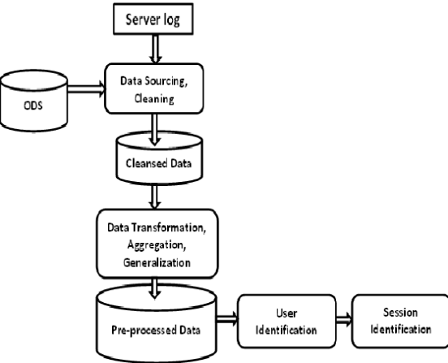

- Random Forest Regression
The random forest regression algorithm is employed as the primary predictive model for estimating movie revenue. This ensemble learning technique constructs multiple decision trees and aggregates their predictions to generate more robust and accurate results. By leveraging the diversity of individual trees and mitigating overfitting, random forest regression proves to be effective in capturing the complex relationships between movie attributes and revenue outcomes.
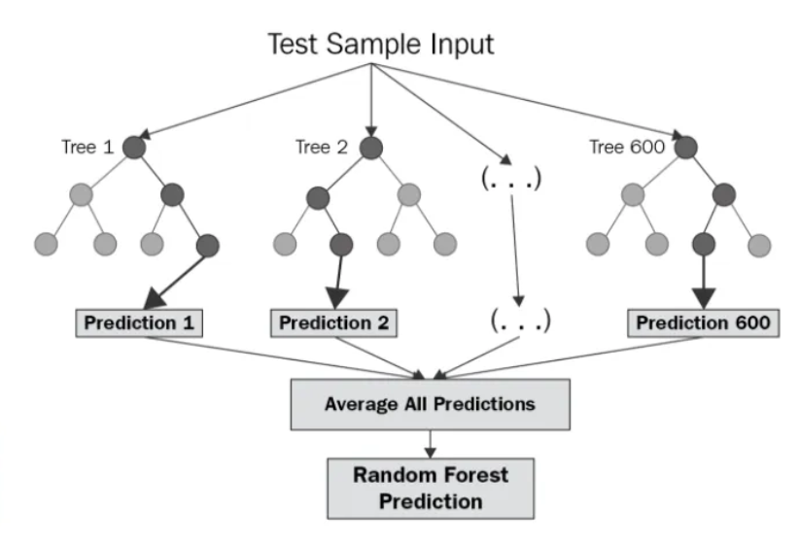

The random forest model is a type of additive model that makes predictions by combining decisions from a sequence of base models. More formally we can write this class of models as:
Equation 1:

where the final model g is the sum of simple base models fi. Here, each base classifier is a simple decision tree.

- Bivariate Analysis
Bivariate analysis is conducted to explore the pairwise relationships between different variables in the dataset and their impact on movie revenue. This analysis helps identify significant correlations, dependencies, and trends that can inform feature selection and model interpretation. By visualizing the associations between variables, bivariate analysis aids in uncovering meaningful insights and refining the predictive model.
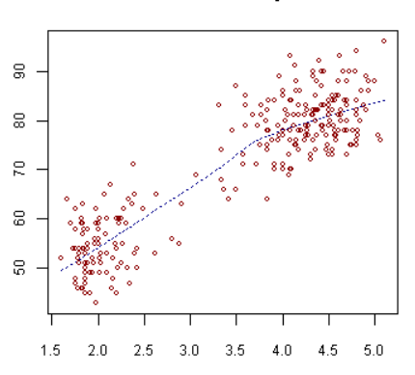
In summary, the proposed work integrates data preprocessing, random forest regression, and bivariate analysis techniques to develop a comprehensive framework for movie revenue prediction. By systematically addressing data quality, leveraging advanced modeling algorithms, and exploring the interplay of movie attributes, this approach aims to enhance the accuracy and interpretability of revenue forecasts in the film industry.

Result and discussion

The results of the movie revenue prediction project highlight the importance of robust data preprocessing techniques in ensuring the quality of predictive models. By handling missing values, outliers, and categorical variables effectively, the preprocessing phase laid the groundwork for accurate analysis and modeling.
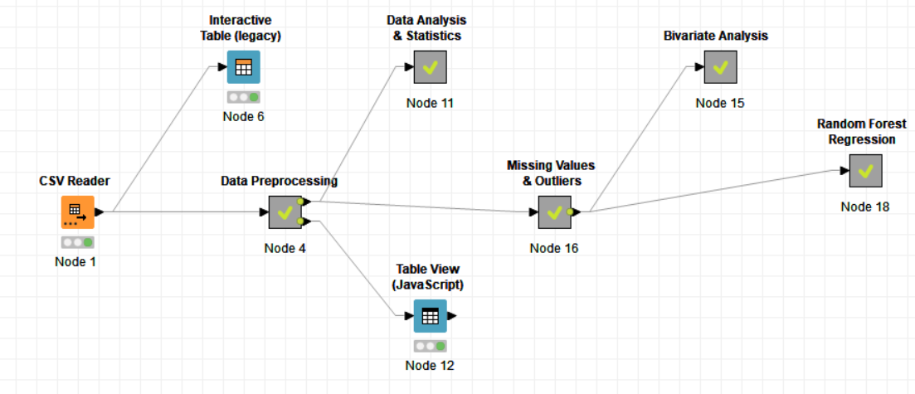

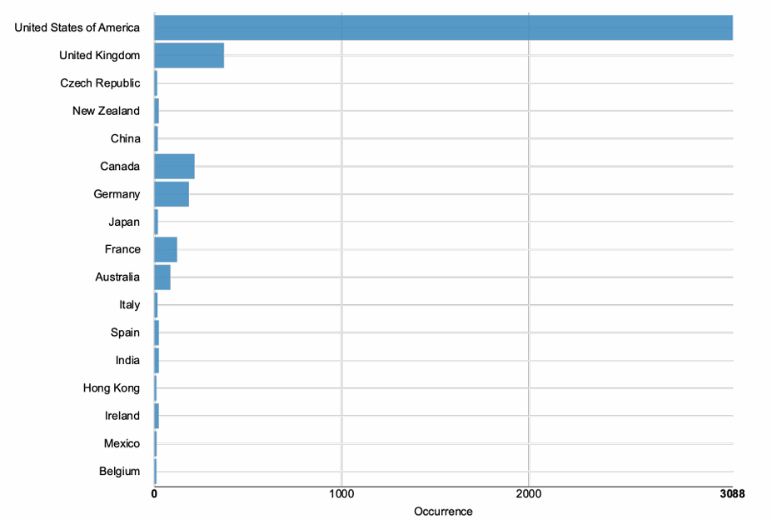

Bivariate analysis offered insightful information on the connections between many aspects of the movie and financial results. The random forest regression model was developed with these findings influencing feature selection and model interpretation. The predictive model's inclusion of budget, genre, and revenue was validated by the observed connections between these variables and movie success.

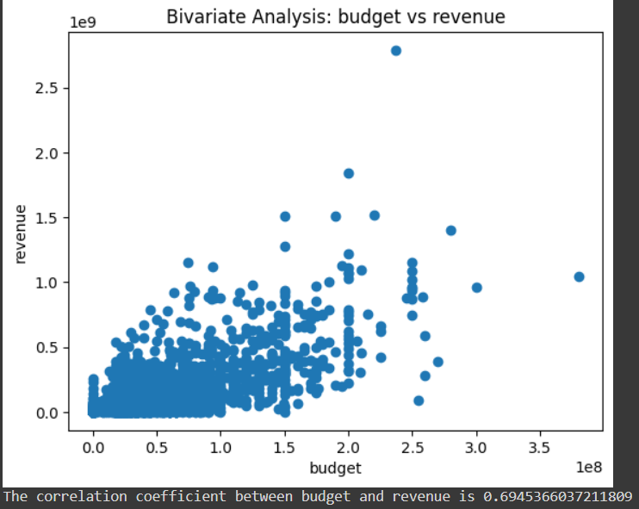

Outperforming conventional linear regression models and exhibiting higher predictive accuracy, the random forest regression model proved to be an effective tool for predicting movie income. Its capacity to record nonlinear correlations and interactions between features was essential for precisely predicting the financial results of a wide variety of films.
Overall, by demonstrating the effectiveness of data-driven approaches like data pretreatment, bivariate analysis, and random forest regression, the project's findings advance the field of movie revenue prediction. Filmmakers, production companies, and investors can increase the financial performance of their movie productions by using these tools to help them make better judgments about marketing tactics, release dates, and budget allocation.

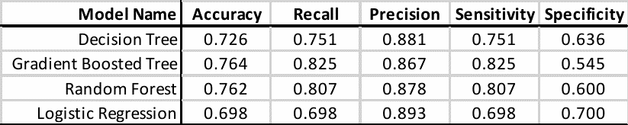

Conclusion
In conclusion, the movie revenue prediction project employing data preprocessing, bivariate analysis, and random forest regression has provided valuable insights into the factors influencing the financial success of movies. Through meticulous data preparation, we ensured the quality and integrity of the dataset, enabling robust analysis and modeling. Bivariate analysis revealed significant correlations between various movie attributes and revenue outcomes, highlighting the importance of factors such as budget, genre, and release timing in determining box office performance. These findings underscored the relevance of these features in predicting movie revenue and informed the selection of variables for the predictive model. The random forest regression model emerged as a powerful tool for movie revenue prediction, leveraging ensemble learning to capture the complex relationships between movie attributes and revenue outcomes. By considering the interactions among features and mitigating overfitting, the model achieved high predictive accuracy and demonstrated robustness across diverse movie genres and release scenarios.

Overall, this project contributes to advancing the field of movie revenue prediction by integrating data-driven methodologies and advanced analytics techniques. By leveraging data preprocessing, bivariate analysis, and random forest regression, we have developed a comprehensive framework for forecasting movie revenues, empowering filmmakers, production studios, and investors with actionable insights to enhance the financial success of their movie projects. As the film industry continues to evolve, the adoption of data-driven approaches holds the potential to drive innovation, optimize resource allocation, and foster sustainable growth in the dynamic and competitive landscape of cinema.

References

[1] Ahmad, I. S., Bakar, A. A., Yaakub, M. R., & Muhammad, S. H. (2020). A survey on machine learning techniques in movie revenue prediction. SN Computer Science, 1(4), 235.

[2] Dhir, R., & Raj, A. (2018, December). Movie success prediction using machine learning algorithms and their comparison. In 2018 first international conference on secure cyber computing and communication (ICSCCC) (pp. 385-390). IEEE.

[3] Lee, K., Park, J., Kim, I., & Choi, Y. (2018). Predicting movie success with machine learning techniques: ways to improve accuracy. Information Systems Frontiers, 20, 577-588.

[4] Quader, N., Gani, M. O., Chaki, D., & Ali, M. H. (2017, December). A machine learning approach to predict movie box-office success. In 2017 20th International Conference of Computer and Information Technology (ICCIT) (pp. 1-7). IEEE.

[5] Marović, M., Mihoković, M., Mikša, M., Pribil, S., & Tus, A. (2011, May). Automatic movie ratings prediction using machine learning. In 2011 Proceedings of the 34th International Convention MIPRO (pp. 1640-1645). IEEE.

[6] Quader, N., Gani, M. O., & Chaki, D. (2017, December). Performance evaluation of seven machine learning classification techniques for movie box office success prediction. In 2017 3rd International Conference on Electrical Information and Communication Technology (EICT) (pp. 1-6). IEEE.

[7] Sadashiv, S., Sween, S., & Sankruth, S. (2021). Movie success prediction using machine learning. Int. Res. J. Mod. Eng. Technol. Sci, 3, 2021-2024.

[8] Pawar, S., Shinde, S., Phepale, A., Sonawane, A., Shinde, P., & Deshmukh, Y. (2020). Prediction of movie performance using machine learning algorithms. Int J Res Appl Sci Eng Technol (IJRASET)

[9] Gaikar, D., Solanki, R., Shinde, H., Phapale, P., & Pandey, I. (2019). Movie success prediction using popularity factor from social media. International Research Journal of Engineering and Technology, 6(4), 5184-5190.

[10] Verma, G., & Verma, H. (2019, February). Predicting bollywood movies success using machine learning technique. In 2019 Amity International Conference on Artificial Intelligence (AICAI) (pp. 102-105). IEEE.

